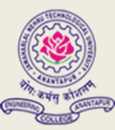
JNTUA COLLEGE OF ENGINEERING (AUTONOMOUS) ANANTHAPURAMU
TEQIP - III sponsored
Three-Day National Workshop
On
RESEARCH AND PUBLICATION ETHICS
20-22 February 2020
REGISTRATION FORM

Name:

Designation:

Sex:

Organization:

Address for Correspondence:

Phone: (O)
E-Mail:
Experience (Years) :
Accommodation Required: YES/NO
Research Area :________________________

Signature

Signature of Head of the Dept/Institution

